1-what is testing
Chapter 1 – Testing - start at 5:01
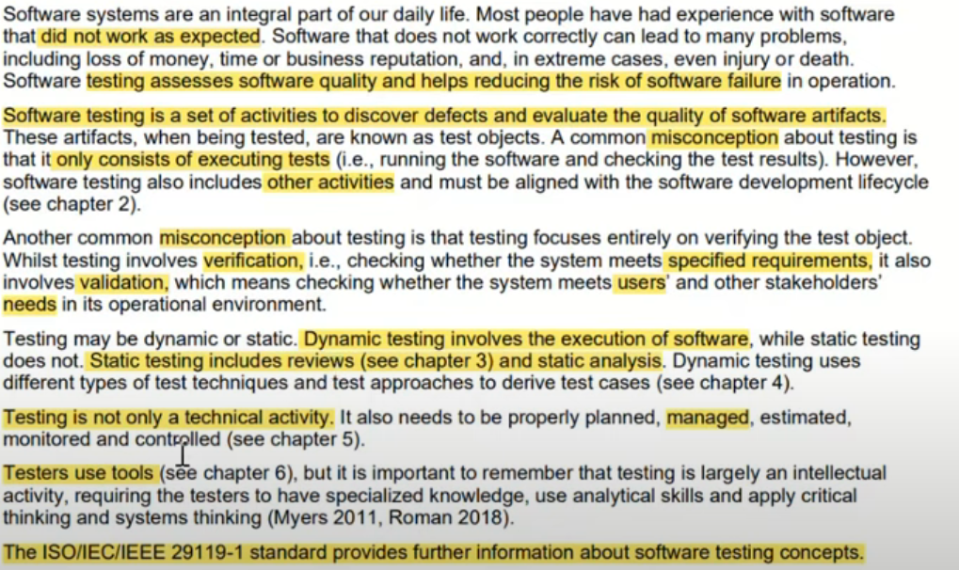

1.1-Test Objectives
Chapter 1 – Testing - start at 13:30
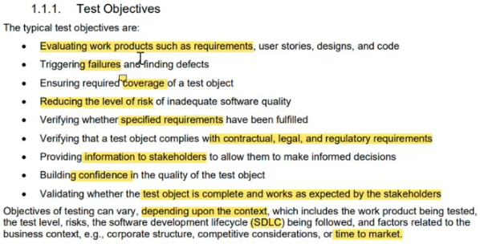

1.1-Testing and Debugging
Chapter 1 – Testing - start at 25:09
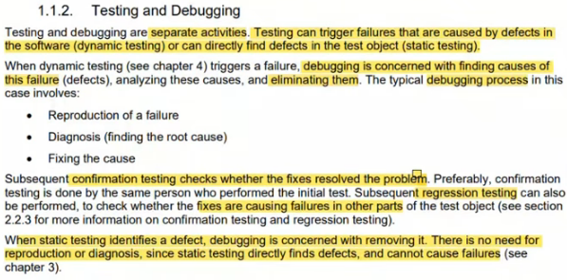

2-Why is testing Necessary
Chapter 1 – Testing - start at 29:57
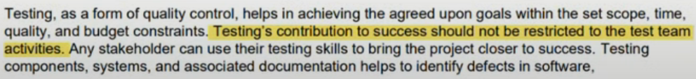

2.1-Testing’s Contributions to Success
Chapter 1 – Testing - start at 30:37
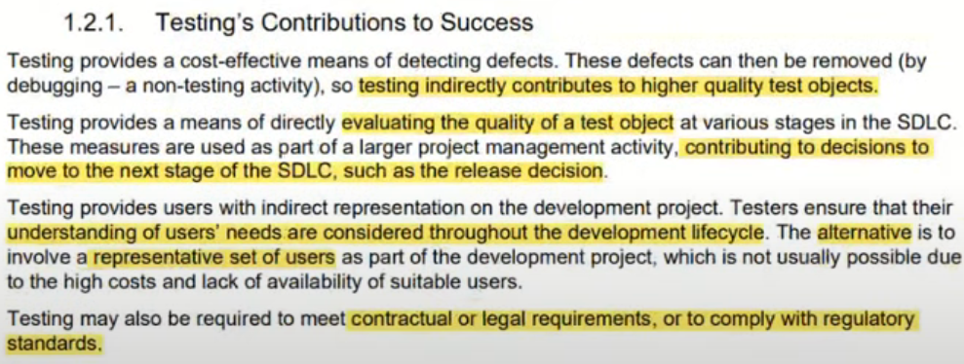

2.2-Testing and Quality Assurance (QA)
Chapter 1 – Testing - start at 33:22
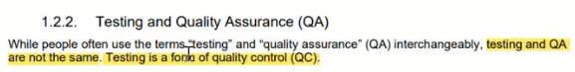
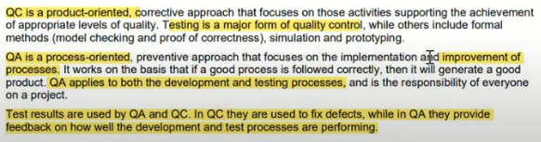

2.3-Errors, Defects, Failures and Root Causes
Chapter 1 – Testing - start at 37:44
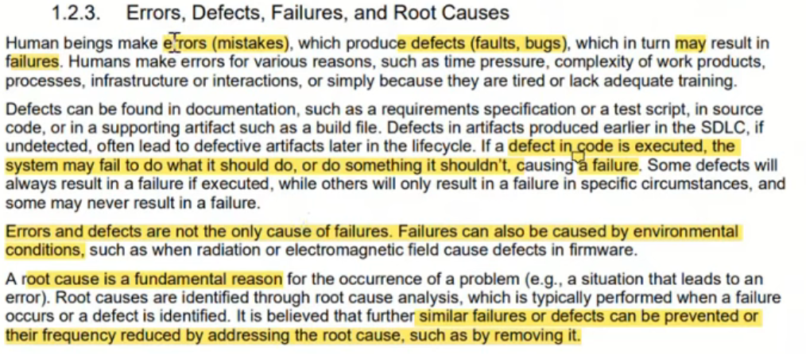

3-Testing Principles
Chapter 1 – Testing - start at 42:32
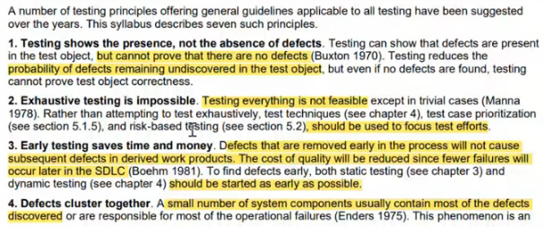
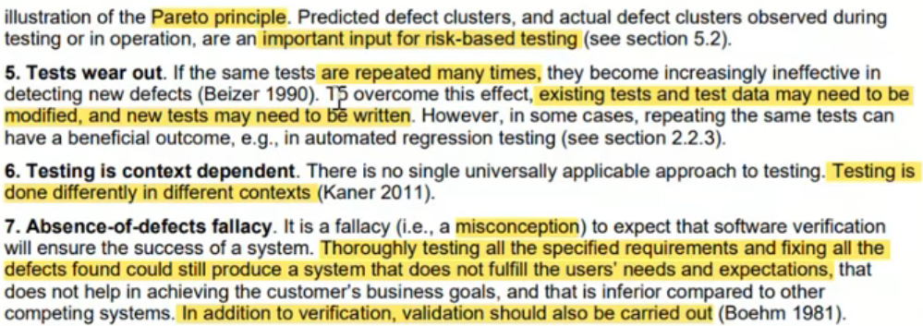

4-Test Activities, Testware and Test Roles
Chapter 1 – Testing - start at 52:02
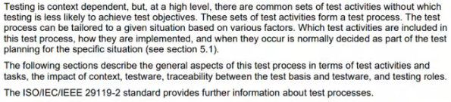

4.1-Test Activates and Tasks
Chapter 1 – Testing - start at 52:02
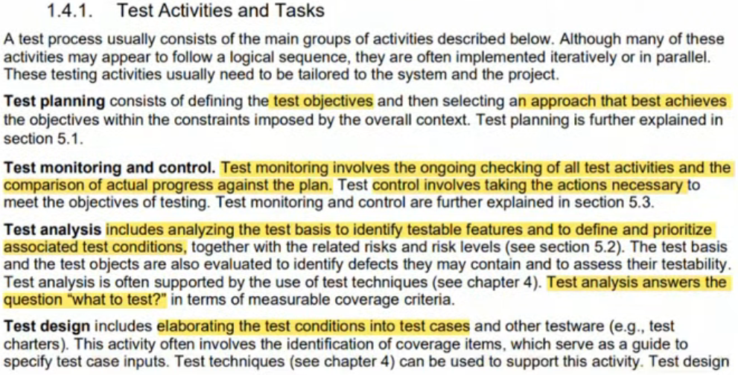
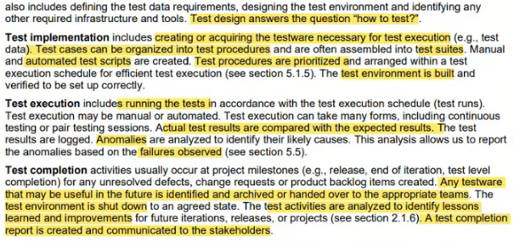

4.2-Test Process in Context
Chapter 1 – Testing - start at 1:06:00
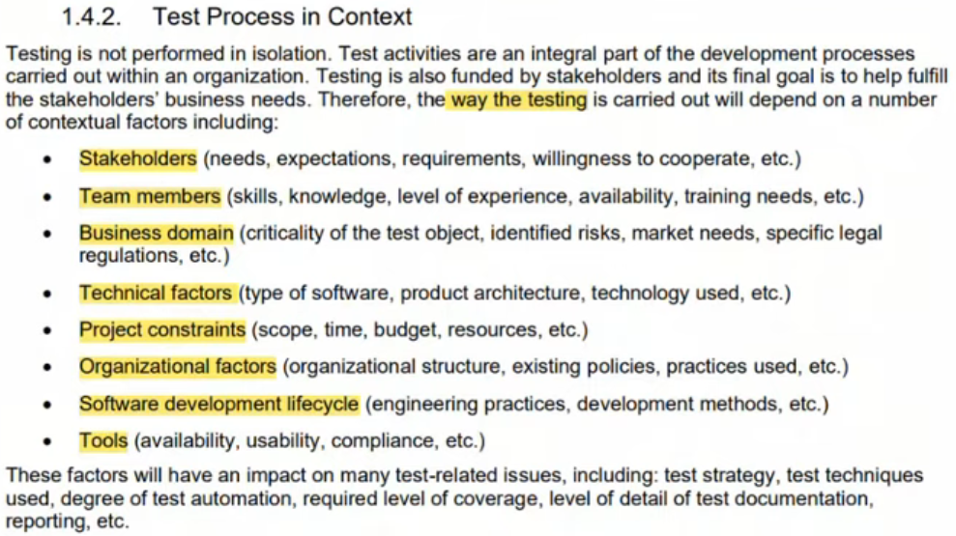

4.3-Testware
Chapter 1 – Testing - start at 1:10:04
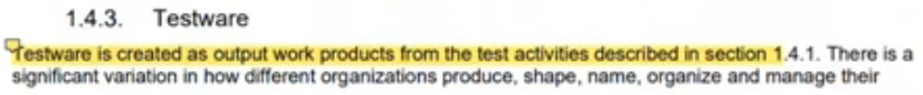
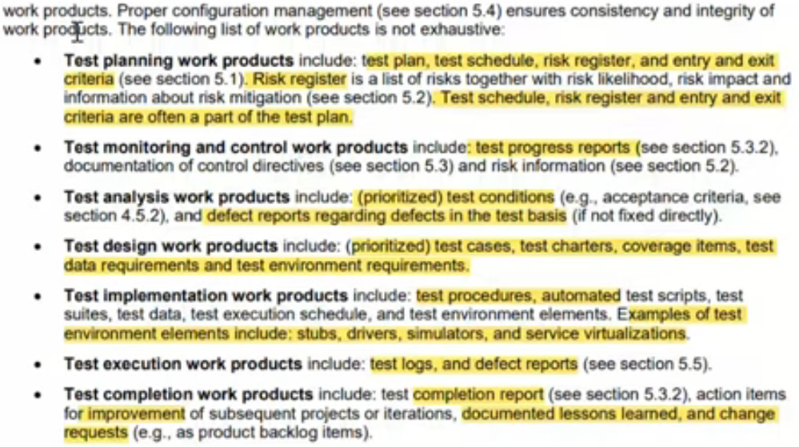

4.4-Traceability between the Test Basis and Testware
Chapter 1 – Testing - start at 1:20:35
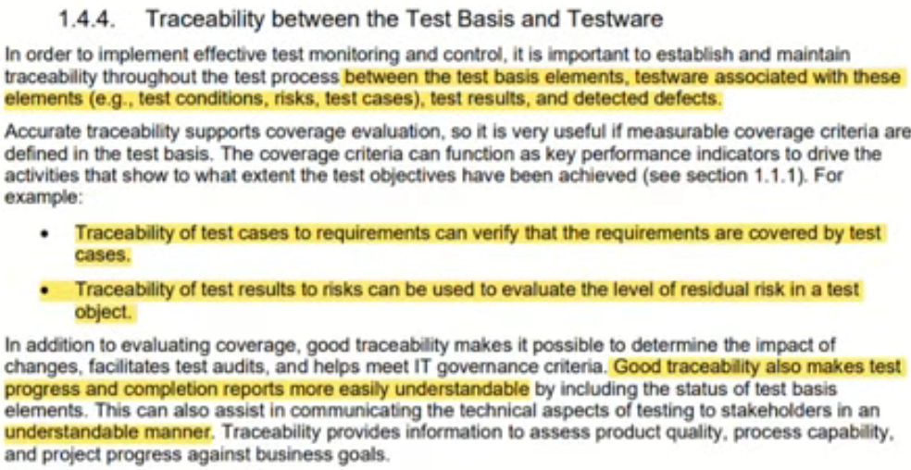

4.5-Roles in Testing
Chapter 1 – Testing - start at 1:23:23
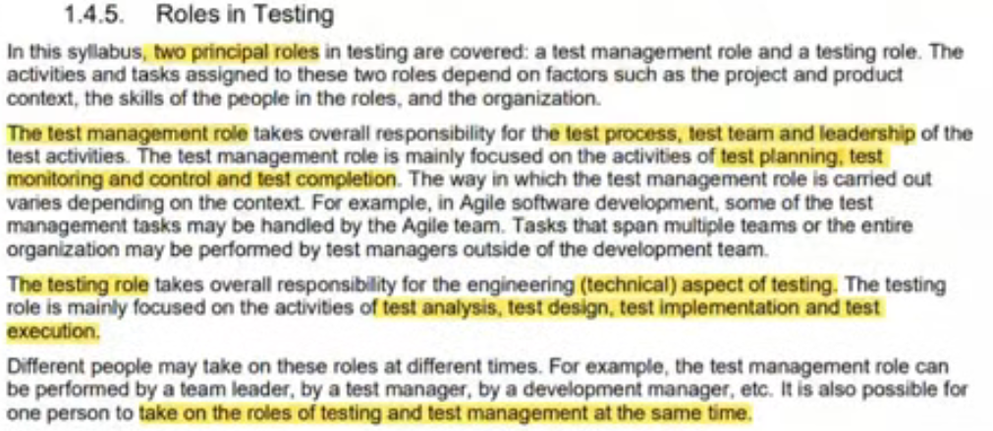

5-Essentials Skills and Good practices in Testing
Chapter 1 – Testing - start at 1:25:27
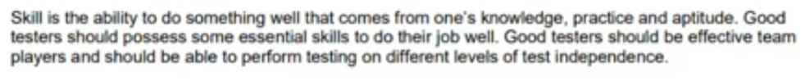

5.1-Generic Skills Required for Testing
Chapter 1 – Testing - start at 1:25:27
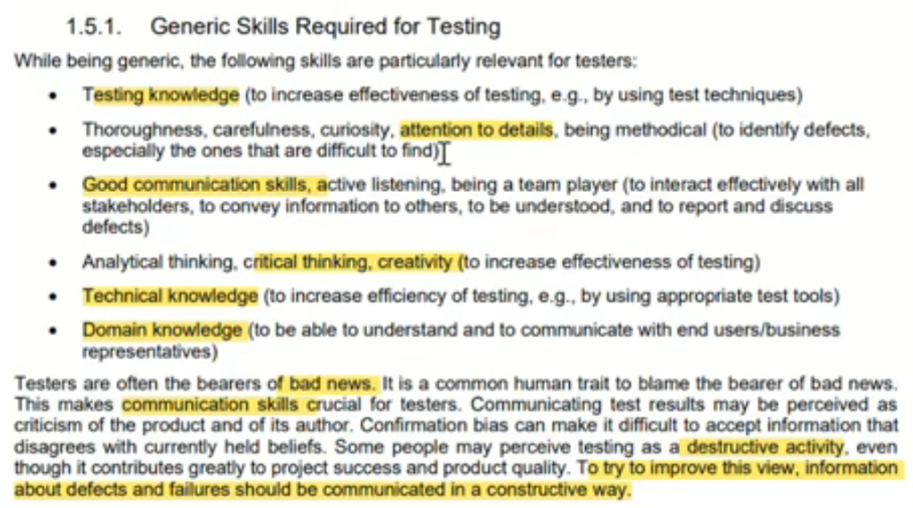

5.2-Whole Team Approach
Chapter 1 – Testing - start at 1:29:10
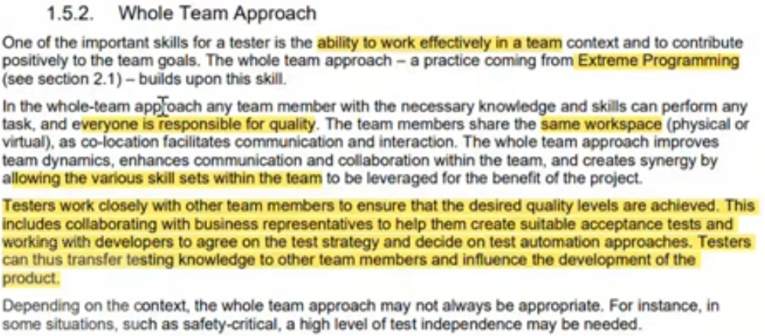

5.3-Independence of Testing
Chapter 1 – Testing - start at 1:31:17
